1. **Fill out the resorce in below table**

|  |  |  |
| --- | --- | --- |
| process | HW system | Name of SW package, language, OS command |
| Install web server |  | Using XAMPP to start APACHE server |
| Install web application |  | Using VSCode to make a web app |
| Install SQL DB server |  | Using phpMyAdmin to connect to MySQL DB server |
| Develop client log in screen |  | Using VSCode create: index.php, login.php, connection.php, test.php, admin.php |
| Create SQL DB table |  | Using phpMyAdmin GUI |
| Create test data (ID, PW data |  | Using phpMyAdmin GUI |
| Create test data (ID, PW data |  |  |

The logic code part, I handle as follows

* Read the value of the form:

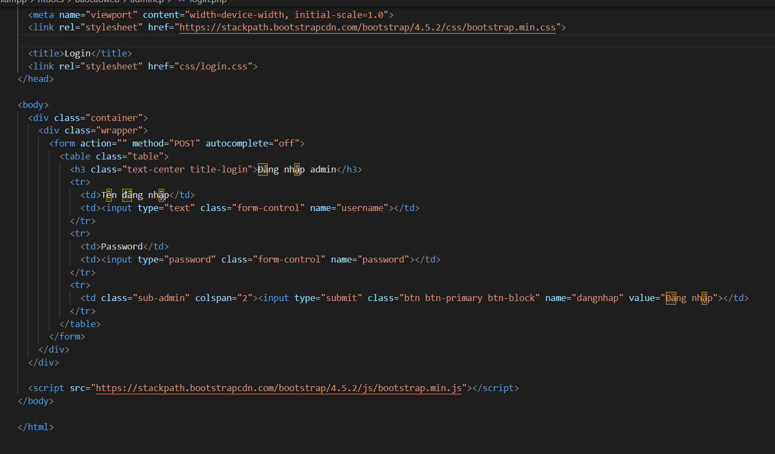

* Log in handling:

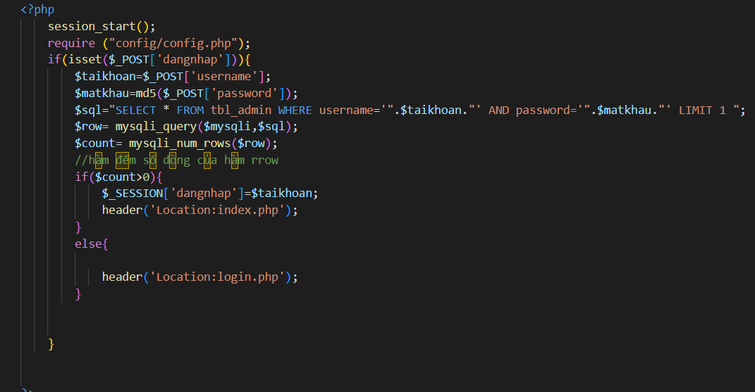

1. Develop client log in screen (if necessary) => screen shot and explain in detail
2. Create SQL DB table (sharing with group table or not?) => screen shot and explain in detail

The application has 3 tables. Products tables stores price and image directory of products. Cart stores the amount of products that user added to the cart. Orders stores information of user during checkout

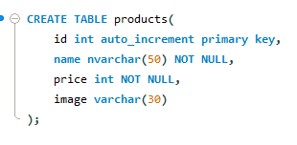

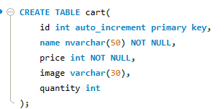

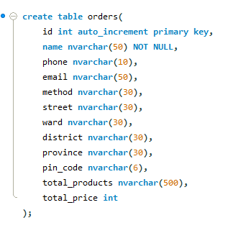

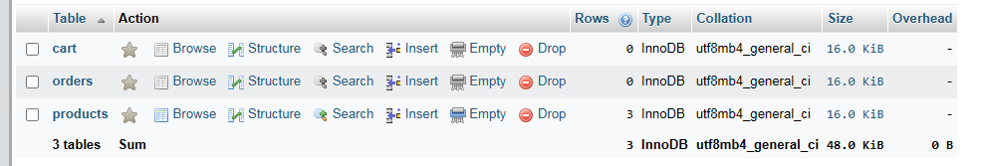

1. Create test data (ID, PW data, sharing with group table or not?) => screen shot and explain in detail

Here are some example data that I’ve inserted for product page

